N-W.F.P UNIVERSITY OF ENGINEERING AND TECHNOLOGY, PESHAWAR.
MID TERM EXAMINATION
4* Semester Civil Engineering Spring 2006
CE-208: STRUCTURAL ANALVSIS-II
Time allowed: 2:15 Hours Max Marks; 25
Note: Attempt all questions. Programmable calculators are not allowed. Q No 1: Analyze the Frame given in FIG 1: by consistent deformation method, (El=Constant),

(9}
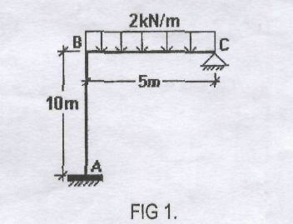

Q No 2: Analyze the Truss given in FIG 2: by method of Least work. (EA=Constant).

(7)
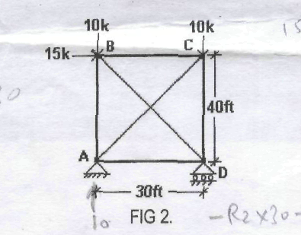

Q No 3: Analyze the Beam given in FIG 3; by slope-deflection method. (EI=Constant).

(9)
