NWFP University of Engineering & Technology Peshawar, Pakistan.

Mid [Term Examination, 2nd semester spring 2006
CE-104 Mechanics of Solids-1
Maximum Marks = 80
Note: Time Allowed = 2hrs
1. All Questions are compulsory and carrying equal Marks 2._ Text Book, Class Notes, and any Programmable calculator are not allowed.
Q)-2
a): Two blocks of wood, width w and thickness t, are glued together along the joint inclined at the angle 6 as shown in the figure. Using the free-body diagram concept, show that the shearing stress on the glued joint is
t = Psin28/2A, Where "A" is the cross-sectional area.
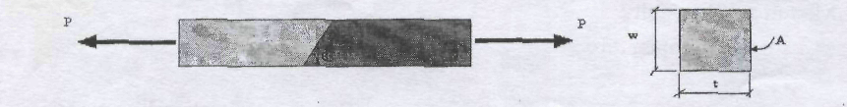
b): An aluminum rod is rigidly attached between a steel rod and a bronze rod as shown in figure. Axial loads are applied at the positions indicated. Find the maximum value of P that will not exceed a stress in steel of HOMPa, in aluminum of 90MPa or in bronze of lOOMPa.

Q)-3
a): State Hooke's Law and Prove the relation as follow,
Where
P= Axial Load, L-length of member, A=x-sectional Area of member, E=modulus of Elasticity
b): The rigid bar ABC shown below is hinged at A and supported by a steel rod at 0. Determine the largest load P that can be applied at C if the vertical movement of end C must not exceed 0.10 in.
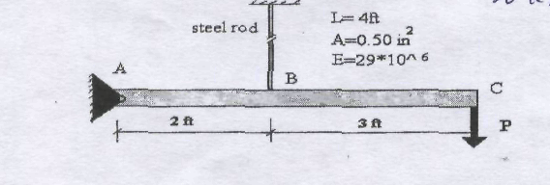
a): Prove that,
o_{t} = aEAT, ot= Thermal stress a = coefficient of linear expansion E = Modulus of Elasticity AT = Change in Temperature
b): A bronze bar 3m long with a cross-sectional Area of 320 mm is placed between two r igid w alls as s hown i n t he figure. A t a t emperature o f - 20 ° C, t he gap i s 2.5mm. Find the temperature at which the compressive stress in the bar will be
35 MPa. Use a - 18*10^{A}-6 m/m. °C and E = 80 GPa.
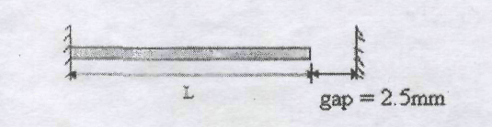
Q)-5"
a): A specimen of any given material is subjected to a uniform tri-axial stress. Determine the theoretical maximum value of poison's ratio.
b): The compound shaft shown below is attached to rigid supports. For the bronze segment AB, the diameter is 75 mm, T < 60 MPa, and G = 35 GPa. For the steel segment BC, the diameter is 50 mm, t < 80 MPa, and G = 83 GPa. Compute the maximum torque T that can be applied.
